**Scripting**

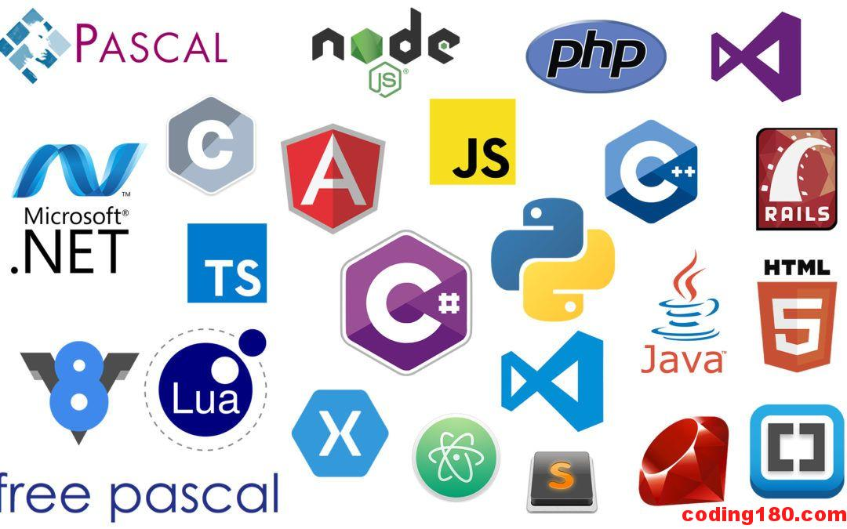

Use the links below and/or research on your own to answer the questions below.

<https://hackr.io/blog/php-vs-javascript>

<https://www.bitdegree.org/tutorials/php-vs-javascript/>

<https://www.guru99.com/php-vs-javascript.html>

<https://www.codesnail.com/2019/02/programming-vs-markup-vs-scripting-languages.html>

1. What is a Scripting Language in Web Development?
2. List the features of Scripting (JavaScript) and Markup Languages (CSS)

|  |  |
| --- | --- |
| Scripting Languages | Markup Languages |
|  |  |

1. What is the difference between a dynamic and static web page?
2. What is the difference between client-side and server side web development?
3. List the features of PHP and JavaScript:

|  |  |
| --- | --- |
| PHP | JavaScript |
|  |  |

1. Give an example of a site and links for each of the following
   1. Site that uses only HTML and CSS
   2. Site that uses only HTML, CSS, and JavaScript
   3. Site that uses PHP